Multiple choice section

|  |  |  |  |  |  |  |  |  |
| --- | --- | --- | --- | --- | --- | --- | --- | --- |
| Question | 1 | 2 | 3 | 4 | 5 | 6 | 7 | 8 |
| Answer | D | A | B | A | B | B | D | A |

Question 1 [7.1]

D

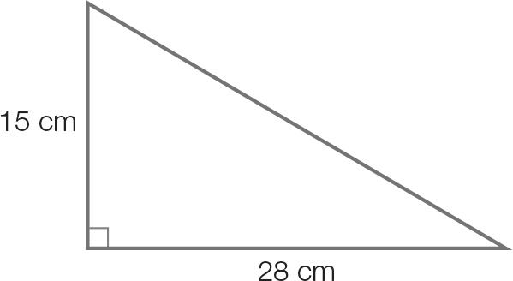

x2 = 152 + 282

x2 = 1009

x =

x = 31.764…

x = 32 cm (correct to the nearest cm)

Question 2 [7.1]

A

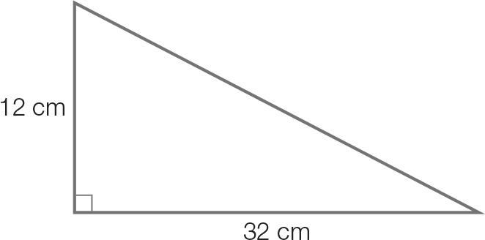

Use the unrounded values in calculations.

x2 = 1009 + 122

x2 = 1153

x =

x = 33.956…

x = 34 cm (correct to the nearest cm)

Question 3 [7.1]

B

CA = 32 cm

HA = 34 cm

cos (θ) = 

θ = cos -1

θ = 19.749…

θ = 20 (correct to the nearest degree)

Question 4 [7.2]

A

sin (212) = sin (180 + 32)

= −sin (32)

Question 5 [7.2]

B

Amplitude =  = 2

Period = 2(150 + 30) = 360

Question 6 [7.3]

B

5 + 10 cos (x) = 0

cos (x) =

cos (x) is negative in the 2nd and 3rd quadrants.

x = 180 + 60 = 240

Question 7 [7.4]

D



x = 

x = 

x = 20 sin (25)

Question 8 [7.6]

A

The third angle of the triangle is (180 – 85 – 65) = 30

A =  × 8 × 10 × sin (30)

=  × 8 × 10 × 0.5

= 20 cm2

Multiple-choice total marks: 8

Short answer section

Question 9 4 marks [7.1]

(a) Find the diagonal distance across the base.  
x2 = 182 + 262  
x2 = 1000  
x =    
x = 31.622…   
x = 31.6 cm (correct to 1 decimal place)

(b) Find the diagonal distance across the rectangular face of the wedge.  
x2 = 222 +262  
x2 = 1160  
x =    
x = 34.058…   
x = 34.1 cm

(c) x2 = 222 – 182  
x2 = 160  
x =    
x = 12.649…   
x = 12.6 cm

(d) Angle ROP will be the same value as angle QNM.

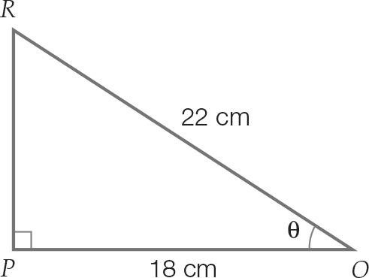

cos (θ) =    
cos (θ) =    
θ = cos-1  
θ = 35.096…  
θ = 35 (correct to the nearest degree)

Question 10 2 marks [7.1]

Length of diagonal on base:  
 (or use 5, 12, 13 Pythagorean triple)

Angle with base: θ = tan-1

= 31.61

Question 11 2 marks [7.1]

Let θ be the angle the straw makes with the base.

sin (θ) = 

θ = sin-1

= 64.79

Question 12 3 marks [7.2]

(a) cos (158) = cos (180 – 22)   
=−cos (22) (cos θ is negative in the 2nd quadrant)

(b) tan (217) = tan (180 + 37)  
= tan (37) (tan θ is positive in the 3rd quadrant)

(c) sin (332) = sin (360 – 28)  
= –sin (28) (sin θ is negative in the 4th quadrant)

Question 13 2 marks [7.2]

−cos (62) in the 1st quadrant means φ is in the 2nd or 3rd quadrant.

In the 2nd quadrant, φ = 180 − 62 = 118

In the 3rd quadrant, φ = 180 + 62 = 242

Question 14 2 marks [7.2]

(a) Period = 60

(b) Amplitude = 1

Question 15 2 marks [7.3]

3 + 5 cos (x) = 0

cos (x) = 

cos (x) is negative in the 2nd and 3rd quadrants

Question 16 4 marks [7.3]

5 sin (θ) + 2 = 0

sin (θ) = 

sin (θ) is negative in the 3rd and 4th quadrants

In the 1st quadrant, θ = sin-1

= 23.58

In the 3rd quadrant, θ = (180 + 23.58) = 203.58

Add and subtract multiples of 360

θ = (203.58 ± 360n), n = 0, 1, 2,…

In 4th quadrant, θ = (360 − 23.58)

= 336.42

Add and subtract multiples of 360

θ = (336.42 ± 360n), n = 0, 1, 2,…

Question 17 2 marks [7.4]

x2 = 22 + 22 – 2 × 2 × 2 cos (θ)

x2 = 8 – 8 cos (θ)

x2 = 8(1 – cos (θ))

x = 

x = 2

Question 18 4 marks [7.4]

(a)

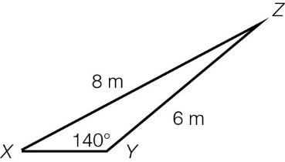

(b)



(c) Remaining angle = 180 − (140 + 29)  
= 11

(d) To find XY you can use the sine rule.  
   
z = 2.374…  
z = 2 m (correct to the nearest metre)

Question 19 4 marks [7.4]

a = 5x, b = 4x, c = 2x

c2 = a2 + b2 – 2ab cos (θ)

(2x)2 = (5x)2 + (4x)2 – 2(5x)(4x) cos (θ)

4x2 = 25x2 + 16x2 – 40x2 cos (θ)

−37x2 = −40x2 cos (θ)



Question 20 4 marks [7.5]

(a)

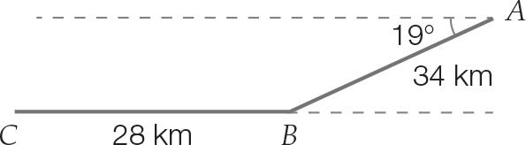

(b)

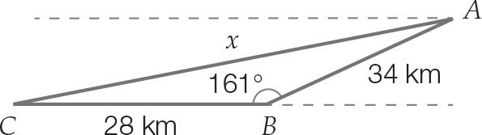

The interior angle of the triangle is (180 – 19) = 161.

Use cosine formula:

Let x be the direct distance for the flight.

x2 = 342 + 282 − 2 × 34 × 28 × cos (161)

= 3740.267

x = 61.158 km

Distance saved

= 34 + 28 – 61.158

= 0.842 km

= 842 m

Question 21 3 marks [7.6]

Angle at intersection of Tan St and Sine Avenue = (45 + 35) = 80

Area =  × 1.6 × 2.2 × sin (80) = 1.73 km2

Question 22 4 marks [7.6]

A =  × a × b × sin (θ)

6a2 =  × 4a × 6a sin (θ)

6a2 = 12a2 sin (θ)

sin (θ) = 

θ = sin-1

θ = 30

Short answer total marks: 42

Extended response section

Question 23 12 marks [7.1, 7.4, 7.5, 7.6]

(a) x2 = 92 + 122 = 152  
x = 15  
height = 12 tan (35)  
= 8.40 249   
d2 = 152 + 8.402  
d2 = 295.56  
d = 17.191 858 54  
d = 17.19 m

(b) θ = cos-1  
= 29.25

(c) cos(35) =   
f =   
= 14.65 m

(d)   
φ = sin-1   
 = 31.57

(e) Area =  × 14.65 × 8.595 × sin (31.57)  
= 32.96 m2

(f) g2 = 14.65…2 + 8.585...2 − 2 × 14.65… × 8.565… × cos (31.57)  
= 73.96…  
g = 8.60 m

Question 24 8 marks [7.2. 7.3]

(a) Period = 12 hours  
Amplitude =  = 2

(b) High tide when x = 3  
Time = 4 am + 3 hours  
= 7 am Sunday

(c) 2.5 = 2 sin (30x) + 1  
1.5 = 2 sin (30x)  
0.75 = sin (30x)  
 30x = sin-1 (0.75)  
 = 48.59, 131.41, 408.59, 491.41  
 x = 1.62, 4.38, 13.62, 16.38

(d) 2(4.38 – 1.62) = 2 × 2.76  
= 5.52 hours

Extended answer total marks: 20

TOTAL test marks: 70